UNITED STATES
SECURITIES AND EXCHANGE COMMISSION
WASHINGTON, D.C. 20549

FORM 8-K

CURRENT REPORT
Pursuant to Section 13 or 15(d) of the Securities Exchange Act of 1934
Date of Report (Date of earliest event reported): October 01, 2026

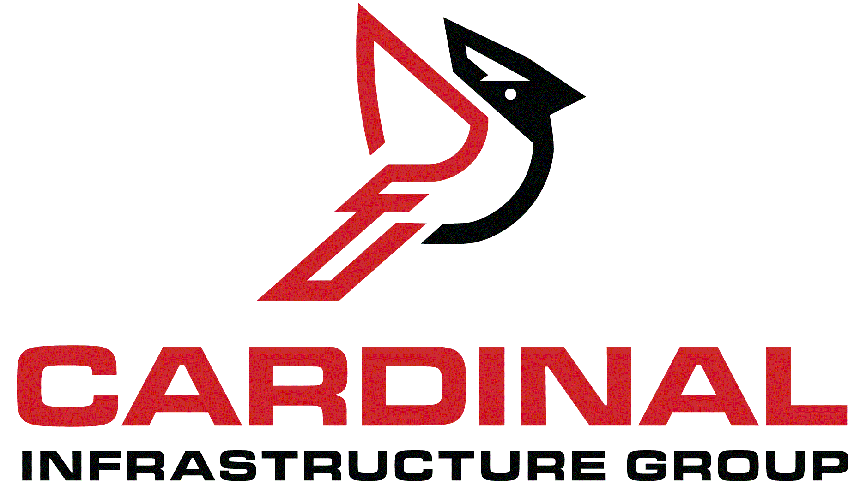
Cardinal Infrastructure Group Inc.
(Exact name of Registrant as Specified in Its Charter)

Delaware |  |  | 001-43004 | 39-3180206
(State or Other Jurisdiction  of Incorporation) |  |  | (Commission File Number) | (IRS Employer  Identification No.)
100 E. Six Forks Road, #300
Raleigh, North Carolina |  |  |  | 27609
(Address of Principal Executive Offices) |  |  |  | (Zip Code)

Registrant’s Telephone Number, Including Area Code: 919 324-1964

(Former Name or Former Address, if Changed Since Last Report)

Check the appropriate box below if the Form 8-K filing is intended to simultaneously satisfy the filing obligation of the registrant under any of the following provisions:
☐Written communications pursuant to Rule 425 under the Securities Act (17 CFR 230.425)
☐Soliciting material pursuant to Rule 14a-12 under the Exchange Act (17 CFR 240.14a-12)
☐Pre-commencement communications pursuant to Rule 14d-2(b) under the Exchange Act (17 CFR 240.14d-2(b))
☐Pre-commencement communications pursuant to Rule 13e-4(c) under the Exchange Act (17 CFR 240.13e-4(c))
Securities registered pursuant to Section 12(b) of the Act:
Title of each class |  | Trading  Symbol(s) |  | Name of each exchange on which registered
Class A Common Stock, $0.0001 Par Value |  | CDNL |  | The Nasdaq Stock Market LLC
Indicate by check mark whether the registrant is an emerging growth company as defined in Rule 405 of the Securities Act of 1933 (§ 230.405 of this chapter) or Rule 12b-2 of the Securities Exchange Act of 1934 (§ 240.12b-2 of this chapter).
Emerging growth company ☒
If an emerging growth company, indicate by check mark if the registrant has elected not to use the extended transition period for complying with any new or revised financial accounting standards provided pursuant to Section 13(a) of the Exchange Act. ☒

Item 3.02 Unregistered Sales of Equity Securities.
On October 1, 2026 (the “Closing Date”), Cardinal Infrastructure Group Inc., a Delaware corporation (the “Company”), consummated its acquisition (the “Acquisition”) of Allied Paving Contractors, Inc. (“Allied Paving”). The Company paid approximately $115.0 million as consideration for the Acquisition, which consisted of (i) an aggregate of approximately $88.9 of cash and (ii) 1,006,796 shares of the Company’s Class A Common Stock, par value $0.0001 per share (the “Shares”). The consideration is subject to customary post-closing adjustments.
The offer and sale of the Shares were made in reliance on the exemption afforded by Section 4(a)(2) of the Securities Act of 1933, as amended (the “Securities Act”) and corresponding provisions of state securities or “blue sky” laws. The Shares were not registered under the Securities Act or any state securities laws and may not be reoffered or resold in the United States absent registration with the Securities and Exchange Commission or an applicable exemption from the registration requirements. The issuance and sale of the Shares did not involve a public offering and were made without general solicitation or general advertising. In addition, each of the recipients of the Shares made representations and warranties to the Company regarding, among other things, as to their status as an accredited investor and investment intent.
Item 7.01 Regulation FD Disclosure.
On October 1, 2026, the Company issued a press release announcing the completion of the acquisition of Allied Paving. A copy of the press release is furnished with this Current Report on Form 8-K as Exhibit 99.1 and incorporated by reference herein.

The information in this Item 7.01 shall not be deemed “filed” for purposes of Section 18 of the Exchange Act or otherwise subject to the liabilities of that section, nor shall it be deemed incorporated by reference in any filing under the Securities Act or the Securities Exchange Act of 1934, as amended, except as expressly set forth by specific reference in such a filing.

Item 9.01 Exhibits.

(d) Exhibits
Exhibit  Number |  | Description
99.1 |  | Press Release, Dated October 1, 2026
104 |  | Cover Page Interactive Data File (embedded within the Inline XBRL document)
______________________

SIGNATURES
Pursuant to the requirements of the Securities Exchange Act of 1934, the registrant has duly caused this report to be signed on its behalf by the undersigned hereunto duly authorized.
 |  |  | CARDINAL INFRASTRUCTURE GROUP INC.
Date: | October 1, 2026 | By: | /s/ Mike Rowe
Mike Rowe
Chief Financial Officer

Exhibit 99.1

Cardinal Infrastructure Group, Inc., Announces Closing of Allied Paving Contractors Acquisition

October 1, 2026

Raleigh, North Carolina – October 1, 2026 – Cardinal Infrastructure Group, Inc., (NASDAQ: CDNL) (“Cardinal” or “the Company”) announced today the closing of its acquisition of Allied Paving Contractors. The acquisition expands Cardinal's self-performing capabilities in the Atlanta market. Allied generated approximately $100 million in revenue on a standalone basis. A portion of that volume will be performed on Cardinal projects and therefore reflected in margin rather than consolidated revenue.

“We’re excited to add Allied’s experienced paving crews to our solutions in Northern Georgia,” said Benji Wood, Chief Operating Officer at Cardinal. “These enhanced capabilities allow us to sequence paving work directly behind our grading and site development teams, shorten project timelines and expand our existing self-perform capabilities to this market. Allied is one of the best in the business and we’re thrilled to bring their customer value proposition to our clients in the Atlanta market.”

John McLean, CEO of Allied, will join the Cardinal leadership team in managing paving operations across Georgia. This acquisition aligns with Cardinal’s strategy of targeting founder-led companies.

About Cardinal
Cardinal Infrastructure Group, Inc., (NASDAQ: CDNL) delivers its suite of comprehensive infrastructure services that support the planning, preparation, installation and development of residential, commercial, industrial and municipal infrastructure projects through wholly owned, market leading subsidiaries. Cardinal’s operations leverage in-house, highly skilled teams and equipment fleets to deliver wet utility installations (water, sewer, and stormwater systems), as well as site clearing, grading, erosion control, drilling and blasting, paving, and other related site services across the Southeast. Cardinal's relationship-based approach is grounded in operational discipline, market expansion, and a commitment to integrity from the ground up.
Forward-Looking Statements
This press release contains forward-looking statements within the meaning of the Private Securities Litigation Reform Act of 1995, including statements about the Company's future performance. Statements that are predictive in nature, that depend upon or refer to future events or conditions or that include the words "may," "could," "plan," "project," "budget," "predict," "pursue," "target," "seek," "objective," "believe," "expect," "anticipate," "intend," "estimate," "will," and other expressions that are predictions of or indicate future events and trends and that do not relate to historical matters identify forward-looking statements. These statements involve risks and uncertainties and Cardinal's actual results could differ materially from the results expressed or implied by such forward-looking statements. The potential risks, uncertainties and other factors that could cause actual results to differ from those expressed by the forward-looking statements in this press release include, but are not limited to, difficulty in sustaining rapid revenue growth, which may place significant demands on Cardinal's administrative, operational and financial resources; fluctuations in Cardinal's revenue and the concentration of Cardinal's business in the Southeastern United States; Cardinal's ability to integrate recent acquisitions and achieve anticipated benefits and synergies; expectations regarding backlog and Cardinal's ability to secure future contracts; expectations regarding demand in the markets that Cardinal serves and in general. Cardinal has based these forward-looking statements largely on its current expectations and projections regarding future events and trends that it believes may affect its business, financial condition and results of operations. The outcome of the events described in these forward-looking statements is subject

to risks, uncertainties and other factors described in the section entitled "Risk Factors" in Cardinal's Annual Report on Form 10-K for the year ended December 31, 2025 (the "Annual Report"), and elsewhere in the Annual Report. Accordingly, you should not rely upon forward-looking statements as predictions of future events. Cardinal cannot assure you that the results, events and circumstances reflected in the forward-looking statements will be achieved or occur, and actual results, events or circumstances could differ materially from those projected in the forward-looking statements. Although forward-looking statements reflect the good faith beliefs of Cardinal's management at the time they are made, forward-looking statements involve known and unknown risks, uncertainties and other factors which may cause actual results, performance or achievements to differ materially from anticipated future results, performance or achievements expressed or implied by such forward-looking statements. Cardinal undertakes no obligation to publicly update or revise any forward-looking statement, whether as a result of new information, future events, changed circumstances or otherwise, unless required by law. These cautionary statements qualify all forward-looking statements attributable to Cardinal or persons acting on its behalf.

Company Contact:
Cardinal Infrastructure Group, Inc.
Mike Rowe, CFO
919-268-6386

